U25AI055
Lab-4
- Find the middle element of a singly linked list.
Example: 11 → 22 → 33 → 44 → 55 → NULL → Middle = 33
// 1. Find the middle element of a singly linked list.
#include <stdio.h>
#include <stdlib.h>
struct Node
{
int data;
struct Node *next;
};
struct Node *findMiddleElement(struct Node *head);
int main()
{
int n;
printf("Enter number of nodes: ");
scanf("%d", &n);
struct Node *head, *newNode, *temp;
head = NULL;
for (int i = 1; i <= n; i++)
{
newNode = (struct Node*)malloc(sizeof(struct Node));
printf("Enter element %d: ", i);
scanf("%d", &newNode->data);
newNode->next = NULL;
if (head == NULL)
{
head = newNode;
temp = newNode;
}
else
{
temp->next = newNode;
temp = newNode;
}
}
printf("Elements of linked list are ");
struct Node *ptr;
ptr = head;
while (ptr != NULL)
{
printf("%d\t", ptr->data);
ptr = ptr->next;
}
printf("\n");
ptr = findMiddleElement(head);
printf("Middle element is %d", ptr->data);
return 0;
}
struct Node *findMiddleElement(struct Node *head)
{
struct Node *p, *q;
q = p = head;
while (p != NULL && p->next != NULL)
{
q = q->next;
p = p->next->next;
}
return q;
}
Output:
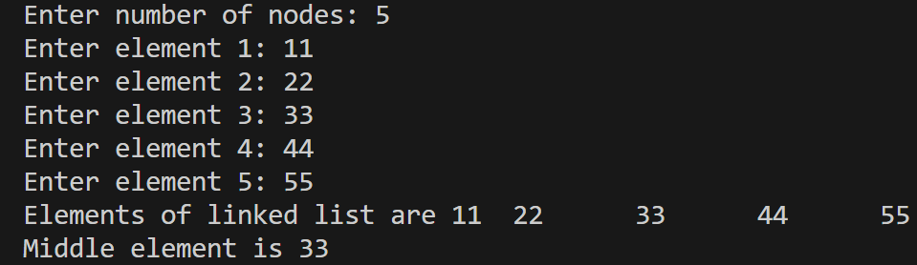
- Detect a loop in a singly linked list.
// 2. Detect a loop in a singly linked list.
#include <stdio.h>
#include <stdlib.h>
struct Node
{
int data;
struct Node *next;
};
int detectLoop(struct Node *head);
struct Node *detectLoopStart(struct Node *head);
int main()
{
struct Node *head, *node1, *node2, *node3;
node1 = (struct Node*)malloc(sizeof(struct Node));
node2 = (struct Node*)malloc(sizeof(struct Node));
node3 = (struct Node*)malloc(sizeof(struct Node));
node1->data = 1;
node1->next = node2;
node2->data = 3;
node2->next = node3;
node3->data = 4;
node3->next = node2;
head = node1;
if (detectLoop(head))
{
printf("Loop start detected at the node whose data is %d\n", detectLoopStart(head)->data);
}
else
{
printf("Loop not detected\n");
}
return 0;
}
int detectLoop(struct Node *head)
{
struct Node *slow, *fast;
slow = fast = head;
while (fast != NULL && fast->next != NULL)
{
slow = slow->next;
fast = fast->next->next;
if (slow == fast)
{
return 1;
}
}
return 0;
}
struct Node *detectLoopStart(struct Node *head)
{
struct Node *slow, *fast;
slow = fast = head;
while (fast != NULL && fast->next != NULL)
{
slow = slow->next;
fast = fast->next->next;
if (slow == fast)
{
slow = head;
while (slow != fast)
{
slow = slow->next;
fast = fast->next;
}
return slow;
}
}
return NULL;
}
Output:
- Remove duplicates from a sorted singly linked list. Example: 2 → 2 → 2 → 5 → 5 → 9 → NULL → 2 → 5 → 9 → NULL
// 3. Remove duplicates from a sorted singly linked list.
#include <iostream>
using namespace std;
struct Node {
int data;
Node *next;
};
void remove_element(Node *head, Node *ptr);
Node* remove_duplicates(Node *head);
int main() {
int n;
cout << "Enter number of nodes: ";
cin >> n;
Node *head, *newNode, *temp;
head = NULL;
for (int i = 0; i < n; i++) {
newNode = new Node;
cout << "Enter element " << i + 1 << ": ";
cin >> newNode->data;
newNode->next = NULL;
if (head == NULL) {
head = newNode;
temp = newNode;
} else {
temp->next = newNode;
temp = newNode;
}
}
Node *ptr;
ptr = head;
while (ptr != NULL) {
cout << ptr->data << "\t";
ptr = ptr->next;
}
cout << endl;
head = remove_duplicates(head);
ptr = head;
while (ptr != NULL) {
cout << ptr->data << "\t";
ptr = ptr->next;
}
return 0;
}
void remove_element(Node *head, Node *ptr) {
Node *p;
p = head;
while (p->next != ptr && p->next != NULL) {
p = p->next;
}
if (p->next == ptr) {
p->next = ptr->next;
delete ptr;
}
}

Node* remove_duplicates(Node *head) {
Node *ptr;
ptr = head;
while (ptr != NULL && ptr->next != NULL) {
while (ptr->next != NULL && ptr->data == ptr->next->data) {
remove_element(head, ptr->next);
}
ptr = ptr->next;
}
return head;
}
Output:
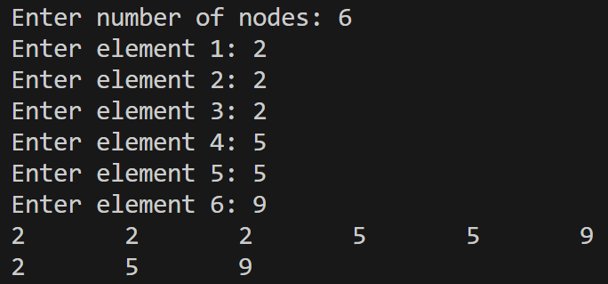
- Clone a linked list with next and random pointers.
// 4. Clone a linked list with next and random pointers.
#include <iostream>
using namespace std;
struct Node {
int data;
Node *random;
Node *next;

};
Node* cloneList(Node *head);
void displayList(Node *head);
int main() {
Node *head, *node1, *node2, *node3, *node4;
node1 = new Node;
node2 = new Node;
node3 = new Node;
node4 = new Node;
head = node1;
node1->data = 1;
node1->next = node2;
node1->random = node3;
node2->data = 3;
node2->next = node3;
node2->random = node3;
node3->data = 5;
node3->next = node4;
node4->random = NULL;
node4->data = 9;
node4->next = NULL;
node4->random = node3;
Node *clone = cloneList(head);
cout << “List cloned” << endl;
return 0;
}
void displayList(Node *head) {
Node *ptr;
ptr = head;
while (ptr != NULL) {
cout << ptr->data << "\t";
ptr = ptr->next;
}
}
Node* cloneList(Node *head) {
Node *clone, *newNode, *temp, *temp1, *temp2, *duplicate, *original;
clone = NULL;
original = head;
while (original != NULL) {
newNode = new Node;
newNode->data = original->data;
newNode->next = NULL;
if (clone == NULL) {
clone = newNode;
temp = newNode;
} else {
temp->next = newNode;
temp = newNode;
}
original = original->next;
}
duplicate = clone; original = head;
while (duplicate != NULL)
{
temp1 = original->next;
original->next = duplicate;
temp2 = duplicate->next;
duplicate->next = temp1;
original = temp1;
duplicate = temp2;
}
original = head;
while (original != NULL && original->next != NULL) {
if (original->random != NULL) {
original->next->random = original->random->next;
}
original = original->next->next;
}
original = head, duplicate = head->next;
while (original != NULL) {
temp = original->next;
original->next = temp->next;
if (duplicate->next != NULL) {
duplicate->next = duplicate->next->next;
}
original = original->next;
duplicate = duplicate->next;
}
return clone;
}
Output:

- Reverse a singly linked list in groups of size k. Example: 1→2→3→4→5→6→7, k=3 → 3→2→1→6→5→4→7
// 5. Reverse a singly linked list in groups of size k
#include <stdio.h>
#include <stdlib.h>
struct Node
{
int data;
struct Node *next;
};
struct Node *reverseListInGroups(struct Node *head, int k);
void displayList(struct Node *head);
int main()
{
int n, i, k;
struct Node *head, *newNode, *temp;
printf("Enter number of nodes: ");
scanf("%d", &n);
head = NULL;
for (i = 1; i <= n; i++)
{
newNode = (struct Node*)malloc(sizeof(struct Node));
printf("Enter element %d: ", i);
scanf("%d", &newNode->data);
newNode->next = NULL;
if (head == NULL)
{
head = newNode;
temp = newNode;
}
else
{
temp->next = newNode;
temp = newNode;
}
}
displayList(head);
printf("\n");
printf("Enter number of nodes in group: ");
scanf("%d", &k);
head = reverseListInGroups(head, k);
displayList(head);
printf("\n");
return 0;
}
struct Node *reverseListInGroups(struct Node *head, int k)
{
int count;
struct Node *ptr, *fast, *slow, *rev, *p, *q;
ptr = head;
slow = fast = NULL;
count = k;
while (ptr != NULL && count != 0)
{
count--;
fast = ptr;
ptr = ptr->next;
fast->next = slow;
slow = fast;
}
rev = fast;
while (ptr != NULL)
{
p = rev;
while (p->next != NULL)
{
p = p->next;
}
slow = fast = NULL;
count = k;
while (ptr != NULL && count != 0)
{
count--;
fast = ptr;
ptr = ptr->next;
fast->next = slow;
slow = fast;
}
q = fast;
if (count != 0)
{
ptr = fast;
slow = fast = NULL;
while (ptr != NULL)
{
fast = ptr;
ptr = ptr->next;
fast->next = slow;
slow = fast;
}
q = fast;
}
p->next = q;
}
return rev;
}
void displayList(struct Node *head)
{
struct Node *ptr;
ptr = head;
while (ptr != NULL)
{
printf("%d\t", ptr->data);
ptr = ptr->next;
}
}
Output:
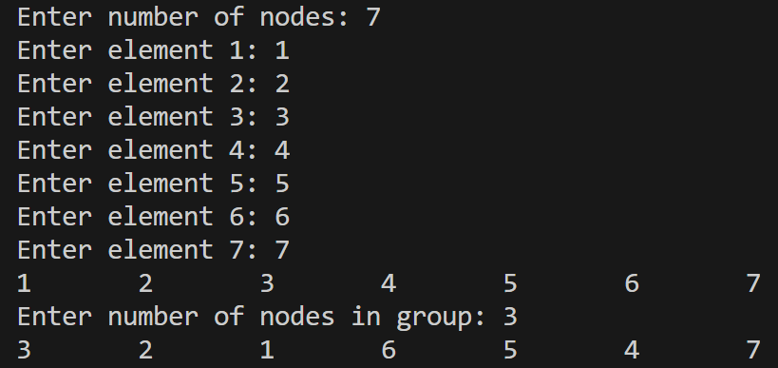
- Check whether a singly linked list is a palindrome. Example: 9 → 8 → 8 → 9 → NULL → Palindrome
// 6. Check whether a singly linked list is a palindrome.
#include <stdio.h>
#include <stdlib.h>
struct Node
{
int data;
struct Node *next;
};
struct Node *reverseList(struct Node *head);
int isPalindrome(struct Node *head);
int main()
{
int n;
printf("Enter number of nodes: ");
scanf("%d", &n);
struct Node *head, *newNode, *temp;
head = NULL;
temp = NULL;
for (int i = 1; i <= n; i++)
{
newNode = (struct Node*)malloc(sizeof(struct Node));
printf("Enter element %d: ", i);
scanf("%d", &newNode->data);
newNode->next = NULL;
if (head == NULL)
{
head = newNode;
temp = newNode;
}
else
{
temp->next = newNode;
temp = newNode;
}
}
struct Node *ptr;
ptr = head;
while (ptr != NULL)
{
printf("%d\t", ptr->data);
ptr = ptr->next;
}
if (isPalindrome(head))
{
printf("\nPalindrome\n");
}
else
{
printf("\nNot palindrome\n");
}
return 0;
}
struct Node *reverseList(struct Node *head)
{
struct Node *p, *q, *ptr;
ptr = head;
q = p = NULL;
while (ptr != NULL)
{
p = ptr;
ptr = ptr->next;
p->next = q;
q = p;
}
head = p;
return head;
}
int isPalindrome(struct Node *head)
{
struct Node *q, *p;
q = p = head;
while (p != NULL && p->next != NULL)
{
q = q->next;
p = p->next->next;
}
q = reverseList(q);
p = head;
while (q != NULL)
{
if (p->data != q->data)
{
return 0;
}
p = p->next;
q = q->next;
}
return 1;
}
Output:
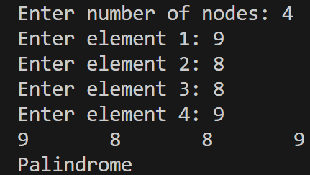
- Move the last node of a linked list to the front. Example: 10 → 20 → 30 → 40 → NULL → 40 → 10 → 20 → 30 → NULL
// 7. Move the last node of a linked list to the front
#include <stdio.h>
#include <stdlib.h>
struct Node
{
int data;
struct Node *next;
};
struct Node *moveLastNodeToFront(struct Node *head);
int main()
{
int n;
printf("Enter number of nodes: ");
scanf("%d", &n);
struct Node *head, *newNode, *temp;
head = NULL;
for (int i = 1; i <= n; i++)
{
newNode = (struct Node*)malloc(sizeof(struct Node));
printf("Enter element %d: ", i);
scanf("%d", &newNode->data);
newNode->next = NULL;
if (head == NULL)
{
head = newNode;
temp = newNode;
}
else
{
temp->next = newNode;
temp = newNode;
}
}
printf("Elements of linked list are ");
struct Node *ptr;
ptr = head;
while (ptr != NULL)
{
printf("%d\t", ptr->data);
ptr = ptr->next;
}
head = moveLastNodeToFront(head);
printf("\nElements of linked list after moving last node to front are ");
ptr = head;
while (ptr != NULL)
{
printf("%d\t", ptr->data);
ptr = ptr->next;
}
return 0;
}
struct Node *moveLastNodeToFront(struct Node *head)
{
struct Node *fast, *slow;
slow = fast = head;
while (fast->next != NULL)
{
slow = fast;
fast = fast->next;
}
slow->next = NULL;
fast->next = head;
head = fast;
return head;
}
Output:
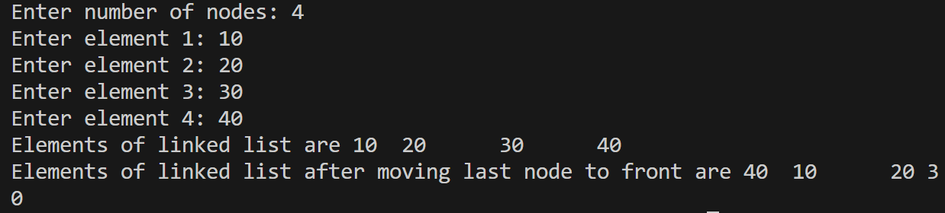
- Merge two sorted singly linked lists into one sorted list. Example: 1→4→8 and 2→3→9 → 1→2→3→4→8→9
// 8. Merge two sorted linked lists into one sorted list
#include <iostream>
using namespace std;
struct Node {
int data;
Node *next;
};
void displayList(Node *head);
Node* mergeLists(Node *head1, Node *head2);
int main() {
Node *head, *head1, *head2, *newNode, *temp;
int n;
head1 = NULL;
cout << "Enter number of nodes: ";
cin >> n;
for (int i = 0; i < n; i++) {
newNode = new Node;
cout << "Enter element " << i + 1 << ": ";
cin >> newNode->data;
newNode->next = NULL;
if (head1 == NULL) {
head1 = newNode;
temp = newNode;
} else {
temp->next = newNode;
temp = newNode;
}
}
head2 = NULL;
cout << "Enter number of nodes: ";
cin >> n;
for (int i = 0; i < n; i++) {
newNode = new Node;
cout << "Enter element " << i + 1 << ": ";
cin >> newNode->data;
newNode->next = NULL;

if (head2 == NULL) {
head2 = newNode;
temp = newNode;
} else {
temp->next = newNode;
temp = newNode;
}
}
displayList(head1);
cout << endl;
displayList(head2);
cout << endl;
head = mergeLists(head1, head2);
displayList(head);
return 0;
}
void displayList(Node *head) {
Node *ptr;
ptr = head;
while (ptr != NULL) {
cout << ptr->data << "\t";
ptr = ptr->next;
}
}
Node* mergeLists(Node *head1, Node *head2) {
if (head1 == NULL) {
return head2;
} else if (head2 == NULL) {
return head1;
}
Node *head, *ptr, *p, *q;
p = head1;
q = head2;
if (p->data <= q->data) {
ptr = p;
p = p->next;
} else {
ptr = q;
q = q->next;
}
ptr->next = NULL;
head = ptr;
while (p != NULL && q != NULL) {
if (p->data <= q->data) {
ptr->next = p;
p = p->next;
} else {
ptr->next = q;
q = q->next;
}
ptr = ptr->next;
}
if (p != NULL) {
ptr->next = p;
} else if (q != NULL) {
ptr->next = q;
}
return head;
}
Output:
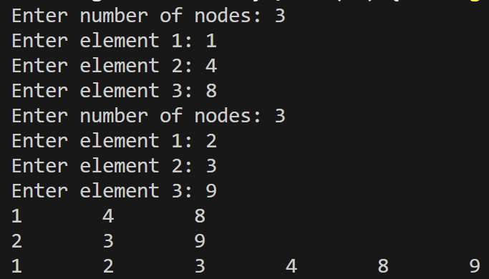
- Find the intersection point of two singly linked lists.
// 9. Find the intersection point of two singly linked lists.
#include <stdio.h>
#include <stdlib.h>
struct Node
{
int data;
struct Node *next;
};
struct Node *findIntersectionPoint(struct Node *head1, struct Node *head2);
int main()
{
struct Node *head1, *head2, *node1, *node2, *node3, *node4, *node5, *node6, *node7;
node1 = (struct Node*)malloc(sizeof(struct Node));
node2 = (struct Node*)malloc(sizeof(struct Node));
node3 = (struct Node*)malloc(sizeof(struct Node));
node4 = (struct Node*)malloc(sizeof(struct Node));
node5 = (struct Node*)malloc(sizeof(struct Node));
node6 = (struct Node*)malloc(sizeof(struct Node));
node7 = (struct Node*)malloc(sizeof(struct Node));
head1 = node1;
node1->data = 4;
node1->next = node2;
node2->data = 1;
node2->next = node3;
node3->data = 8;
node3->next = node4;
node4->data = 5;
node4->next = NULL;
head2 = node5;
node5->data = 5;
node5->next = node6;
node6->data = 6;
node6->next = node7;
node7->data = 1;
node7->next = node3;
printf("The intersection point is the node whose data is %d\n", findIntersectionPoint(head1, head2)->data);
return 0;
}
struct Node *findIntersectionPoint(struct Node *head1, struct Node *head2)
{
struct Node *p, *q;
p = head1;
while (p != NULL)
{
q = head2;
while (q != NULL)
{
if (q == p)
{
return q;
}
q = q->next;
}
p = p->next;
}
return NULL;
}
Output:
- Flatten a linked list having next and bottom pointers into a single sorted list. Output: 5 -> 7 -> 8 -> 10 -> 19 -> 20 -> 22 -> 28 -> 40 -> 45
// 10. Flatten a linked list having next and bottom pointers into a single sorted list.
#include <stdio.h>
#include <stdlib.h>
struct Node
{
int data;
struct Node *next;
struct Node *bottom;
};
struct Node *flattenList(struct Node *head);
struct Node *mergeLists(struct Node *head1, struct Node *head2);
int main()
{
int i;
struct Node *result, *head, *nodes[10];
for (int i = 0; i < 10; i++)
{
nodes[i] = (struct Node*)malloc(sizeof(struct Node));
}

head = nodes[0];

nodes[0]->data = 5;
nodes[0]->next = nodes[1];
nodes[0]->bottom = nodes[4];

nodes[1]->data = 10;
nodes[1]->next = nodes[2];
nodes[1]->bottom = nodes[6];

nodes[2]->data = 19;
nodes[2]->next = nodes[3];
nodes[2]->bottom = nodes[7];

nodes[3]->data = 28;
nodes[3]->next = NULL;
nodes[3]->bottom = nodes[8];

nodes[4]->data = 7;
nodes[4]->next = NULL;
nodes[4]->bottom = nodes[5];

nodes[5]->data = 8;
nodes[5]->next = NULL;
nodes[5]->bottom = NULL;

nodes[6]->data = 20;
nodes[6]->next = NULL;
nodes[6]->bottom = NULL;

nodes[7]->data = 22;
nodes[7]->next = NULL;
nodes[7]->bottom = NULL;

nodes[8]->data = 40;
nodes[8]->next = NULL;
nodes[8]->bottom = nodes[9];

nodes[9]->data = 45;
nodes[9]->next = NULL;
nodes[9]->bottom = NULL;

result = flattenList(head);
struct Node *ptr;
ptr = result;
while (ptr != NULL)
{
printf("%d\t", ptr->data);
ptr = ptr->bottom;
}
return 0;
}
struct Node *flattenList(struct Node *head)
{
struct Node *ptr, *result;
result = head;
ptr = head->next;
result->next = NULL;
while (ptr != NULL)
{
struct Node *temp = ptr->next;
ptr->next = NULL;
result = mergeLists(result, ptr);
ptr = temp;
}
return result;
}
struct Node *mergeLists(struct Node *head1, struct Node *head2)
{
struct Node *head, *ptr, *p, *q;
p = head1;
q = head2;
if (p->data <= q->data) {
ptr = p;
p = p->bottom;
} else {
ptr = q;
q = q->bottom;
}
ptr->bottom = NULL;
head = ptr;
while (p != NULL && q != NULL) {
if (p->data <= q->data) {
ptr->bottom = p;
p = p->bottom;
} else {
ptr->bottom = q;
q = q->bottom;
}
ptr = ptr->bottom;
}
if (p != NULL) {
ptr->bottom = p;
} else if (q != NULL) {
ptr->bottom = q;
}
return head;
}
Output:
- Merge K sorted linked lists into one sorted linked list. Example: L1=1→5, L2=2→6, L3=3→4 → 1→2→3→4→5→6
// 11. Merge k sorted linked lists into one sorted linked list
#include <iostream>
using namespace std;
struct Node {
int data;
Node *next;
};
void displayList(Node *head);
Node* mergeKLists(Node *heads[], int k);
Node* mergeLists(Node *head1, Node *head2);
int main() {
int k, n;
cout << "Enter k: ";
cin >> k;
Node *heads[k], *newNode, *temp, *head;
for (int i = 0; i < k; i++) {
heads[i] = NULL;
cout << "Enter number of nodes: ";
cin >> n;
for (int j = 0; j < n; j++) {
newNode = new Node;
cout << "Enter element " << j + 1 << ": ";
cin >> newNode->data;
newNode->next = NULL;
if (heads[i] == NULL) {
heads[i] = newNode;
temp = newNode;
} else {
temp->next = newNode;
temp = newNode;
}
}
}
for (int i = 0; i < k; i++) {
displayList(heads[i]);
cout << endl;
}
head = mergeKLists(heads, k);
displayList(head);
cout << endl;
return 0;
}
void displayList(Node *head) {
Node *ptr;
ptr = head;
while (ptr != NULL) {
cout << ptr->data << "\t";
ptr = ptr->next;
}
}
Node* mergeKLists(Node *heads[], int k) {
if (k == 0) {
return NULL;
}
for (int i = 0; i <= k - 2; i++) {
heads[i + 1] = mergeLists(heads[i], heads[i + 1]);
}
return heads[k - 1];
}
Node* mergeLists(Node *head1, Node *head2) {
if (head1 == NULL) {
return head2;
} else if (head2 == NULL) {
return head1;
}
Node *head, *ptr, *p, *q;
p = head1;
q = head2;
if (p->data <= q->data) {
ptr = p;
p = p->next;
} else {
ptr = q;
q = q->next;
}
ptr->next = NULL;
head = ptr;
while (p != NULL && q != NULL) {
if (p->data <= q->data) {
ptr->next = p;
p = p->next;
} else {
ptr->next = q;
q = q->next;
}
ptr = ptr->next;
}
if (p != NULL) {
ptr->next = p;
} else if (q != NULL) {
ptr->next = q;
}
return head;
}
Output:
